Forests 101 Program
Stewardship Association of Municipalities (SAM)

Created by: Outreach Coordinator Karleena Squires

This programming is appropriate for grades K-12 - activities can be chosen/adapted based on their ages. This program can be delivered in person or virtually and provides instructions for both.

OBJECTIVE

Participants will spend time in the forest, and/or spend time learning about the forest, in order to understand how and why forests are an important ecosystem within Newfoundland and Labrador. This program provides some building blocks for a lifetime of active and thoughtful engagement with forests and other natural spaces. Participants will:
- Engage with their local forests through exploration and conservation activities;
- Experience time in or learning about nature (specifically, forests) that is beneficial to their mental and physical well-being, which can encourage continued exploring of nature;
- Learn about forests and how they are an interconnected web of resources that face a variety of threats, including fire, invasive species, loss of open space, and unmanaged recreation, and be able to understand how to protect them;
- Explain the benefits of forests to our communities;

OUTLINE

- Introduction
- Activity (complete at least 3-5 activities depending on the event’s time length and age of the group)
All Ages / Younger Groups / Older Groups
  - Interpretive Walk
  - Be the Web*
  - What am I?
  - Timber Tag
  - Forestry Art
  - Producing Paper
  - Green Habits
  - Community Engagement**
*This activity has multiple versions
**We encourage the older groups to complete or plan a community engagement project as one of their activities.
- Closing
Prior to the meeting, confirm time, location(s), number of attendees, and presence of supplies with the group/class leader.

INTRODUCTION

- Introduce yourself - who are you, your position, what you do, etc.
- Land Acknowledgement: In the spirit of respect and friendship, we acknowledge that we practice conservation on traditional lands that have been, and continue to be, inhabited by the Indigenous Peoples of Newfoundland and Labrador. We are thankful to all the generations of people who have cared for these lands, and recognize and deeply appreciate their historic connections to these places. SAM recognizes our shared responsibility in conserving these special places and seeks to assist communities in achieving this goal.
- Introduce SAM, here are a few important notes:
  - SAM helps protect important habitats in our province.
  - What is a habitat?
    - Everything an animal or plant needs to survive: all habitats need to have food, shelter and water.
  - What are some examples of habitats in your community?
  - SAM helps to protect important habitats within many communities across the province. (Include an example from their community if they are a SAM Community).
  - What are some threats that we would need to protect these habitats from?
    - Climate change, development, pollution, flooding, etc.
  - Present the Forestry 101 Presentation - you will notice there are speakers’ notes on the slide, you can use these to compliment the slides and provide more information.

ACTIVITY: INTERPRETIVE WALK

- In person - invite SAM to help run your walk or run it yourself!
- If the weather permits, do this programming outside.
- Start the event off with an interpretive walk - other programming activities can be provided along the walk.
- Ideal walking locations: local trail, local forest, Provincial/Community Park
- Provide information about forests, wildlife habitats, and other interesting facts. while in the field that you would provide in the presentation when indoors/virtual (can be found in the Speaker’s Notes).
- Bring along some magnifying glasses or lenses for a more up close look!

ACTIVITY: BE THE WEB

- In person or virtual
- Supplies:
  - Virtual: Google Form - https://forms.gle/7nydPbs3tFqe9P5n7
  - In Person: Can be played one of two ways: Option 1 requires a roll of string/yarn, Option 2 requires no supplies
- Discuss:
  - What is an ecosystem?
    - All the organisms and the physical environment with which they interact.
    - A healthy forest ecosystem has a diverse group of plants and animals that share the resources so all life is supported.
- In Person Option 1 instructions:
  - Assign each person in the group a role out of the list in Appendix A - either by printing them out and taping them to their shirts (there are some blanks in case you need extras), or by verbally assigning - one person must be the sun (stand in the center), then divide the rest up evenly.
  - Explain that all living things need energy to live. Flowers need energy to grow, birds need energy to fly, etc. They all get their energy from their food source: plants get theirs from the sun, animals eat plants or other animals, and so on. This is called a food chain. Interacting food chains are called a food web.
  - At the beginning, ask them - who in the circle can give “you” (as in their assigned role) energy? Have a few kids answer. Then ask them - who in the circle can “you” give energy to?
  - Explain that the string represents the energy from the sun being shared.
  - The sun holds the loose end of the yarn and tosses the ball to someone who can use the energy (a plant).
  - They in turn toss it to the next in the food chain (a plant-eater).
  - Keep going until the yarn has reached a carnivore (meat-eater) or omnivore (plant- and animal-eater) that is at the top of the food chain (has no known predators). You have now completed a food chain!
  - The last person to receive the yarn then passes the yarn ball back to the sun (keep it connected) and thus they start another food chain.
  - Continue until everyone has at least one piece of string in their hands (some may have multiple).
  - Discuss:
    - We started off with one food chain, and then another and then another…
    - What do all of our food chains together look like? (A food web)
    - Who is holding the most pieces of yarn and why? (The sun, because every food chain starts with the sun)
    - What else is part of many food chains (Green plants)
    - What would happen if any of these organisms were to disappear? Have 1 member drop the yarn they are holding. Does it affect the food web?
- In Person Option 2 instructions:
  - A food web shows the feeding relationships within an ecosystem and can be divided into 3 parts:
    - Producers: plants that use energy from the sun to grow
    - Consumers: animals that eat plants or other animals to gain energy to grow
    - Decomposers: fungi, bacteria, or invertebrates that consume dead or decaying plant or animal material
  - ​In this game, students will assume these roles to see how these three groups can interact in a simplified way.
    - Assign at least 1 consumer and 1 decomposer, you can add more if it is a larger group.
    - The rest are producers
    - Consumers “eat” (tag) the producers - who fall to the ground and freeze in position once tagged
    - Decomposers recycle the dead producers into nutrients for new producers to grow - they tag the frozen producers “bringing them back to life”
  - After several minutes you can switch up the consumers and decomposers so more have turns being “it”
  - Ask them:
    - How is this tag game a cycle?
    - What was passed from one player to the next?
    - What role do the decomposers play in the cycle?
    - What would happen without the decomposers?
    - What would happen if any of these organisms were to disappear? Does it affect the food web? The cycle of nutrients?
- Virtual Option: Use the Google Form “Be the Web: Choose Your Own Adventure” for a fun-filled choose your own food web adventure. Optional: Have someone record the food chains as they are chosen on a blank jamboard/piece of paper and then connect your food chains at the end to form a food web.
  - https://forms.gle/7nydPbs3tFqe9P5n7
  - Discuss:
    - What was passed from one animal to the next?
    - Were there any plants/animals that were used in multiple food chains?
    - If you didn’t record the food chains, ask them: how do all of these plants and animals interact? (They are present in multiple food chains)
    - What would happen if any of these organisms were to disappear? Does it affect the food web?

ACTIVITY: WHAT AM I?

- In person or virtual (virtual option can also be done in person with a projector and screen or large screen such as a laptop for older age groups)
- Supplies:
  - Virtual (all ages): “What am I?” slides at the end of the Forestry 101 Presentation
  - In Person (younger kids): Either a small bag that you cannot see into, or a covered box with a hole in one side large enough for a hand to fit through, a collection of items found in nature (pine cone, leaf, rock, moss, branch, etc, approximately 5-10 items)
- In Person: Have the items hidden from view from participants. One at a time, put one of the items secretly in the box or bag. Allow participants one at a time to feel the object. Once everyone has felt, allow them to guess what the object is.
- Virtual: Show the zoomed in slide and have participants try to guess what the objects are.

ACTIVITY: FOREST SCAVENGER HUNT

- In person or virtual.
- Supplies: Scavenger Hunt List in Appendix B
- Virtual: Provide your group with their scavenger hunt sheets to complete in a local forest on their own time.
- In Person: Visit a local forest and complete the scavenger hunt.
- Can’t get out to an actual forest? Hide photos around the room for them to “find”.

ACTIVITY: TIMBER TAG

- In person
- Supplies needed: some sort of “token”, enough for everyone to have 2 each - this can be crayons, marbles, etc
- Backstory: Newfoundlanders and Labradorians have had a long standing relationship with our forests. In the early days, our forests were used almost exclusively to support our fishery. Nowadays our forests have many uses: from pulp and paper, to recreational uses, and more. In the 1990s, the Forestry Act was initiated to not only manage our timber resources, but to include the management of forests considering other resource management objectives including environmental practices and sustainable development.
- In this game of tag, you will observe one of the many ways that loggers can help protect our forests and its resources.
- Instructions:
  - Assign roles: 1-2 loggers, 1-2 resource managers, everyone else is a tree
  - Trees are given 2 tokens
  - Loggers try to tag the trees, once a tree is tagged they give the logger one of their tokens - this means they have lost one branch. When loggers receive tokens, they must give them to the Resource Managers. Once they are tagged a second time, they give up their second token and they are “chopped down” - they drop to the floor as a stump.
  - Resource Managers protect the forest by planting new trees - they tag stumps and give them 2 new tokens and now they are a re-planted tree.
  - Discuss:
    - What would happen if there were no Resource Managers?
    - What would happen if there were more Loggers than Resource Managers?
    - Why are Resource Managers important?
    - How could people, animals, and nature be affected if too many trees were chopped down or if there were no Resource Managers?
    - What can you do to protect trees?

ACTIVITY: FORESTRY ART

- In person or virtual
- Supplies:
  - If meeting virtually, ask the group to collect their materials prior to the meeting.
  - They will need: materials found on the forest floor - take only what is dead and no longer necessary so as not to disturb the ecosystem (leaves, twigs, dead flowers, etc), glue, cardboard/poster board
- Use the materials you found to create an artistic display - be as creative as you’d like!

ACTIVITY: PRODUCING PAPER

- In person or virtual (note this requires drying overnight)
- Supplies:
  - Newspaper sheets (approximately 1.5 sheets) for the pulp, large sheet of cotton or canvas to soak up excess water (such as a pillow case), large square or rectangular pan (no larger than 12x12 inches) about 3 inches deep, 3 cups of water, piece of window screen that will fit in the pan (available at a hardware store), rolling pin, blender
- Paper is one of the many products that we get from trees, sadly a lot of that paper ends up as waste in the trash. In Newfoundland and Labrador we have a paper product recycling program that takes everything from sheets of paper to cardboard and more. Recycling paper helps to reduce greenhouse gas emissions that can contribute to climate change. It takes 70% less energy and water to recycle paper than to create new paper from trees. Using recycled paper helps cut down on pollution! We are going to be making our own recycled paper!
- Instructions:
  - Tear the 1.5 sheets of newspaper or several sheets of paper into tiny pieces
  - This step may require adult supervision/help: Place the paper and water into a blender and carefully blend on medium speed for about 5 seconds. You now have pulp!
  - Place the window screen in the pan and cover with about an inch of water.
  - Pour about one cup of the pulp over the screen and spread it around with your fingers. This will become your sheet of paper.
  - Carefully lift the screen flat and let the water drain into the pan. Place the screen with pulp onto your sheet of cotton/canvas to absorb the excess water.
  - Fold the cotton/canvas sheet over the top and then flip it so the screen is on the top inside.
  - Using the rolling pin, roll over the top of the sheet/canvas to help remove the excess water from the pulp.
  - Uncover your paper and carefully remove the screen.
  - Leave the newly made sheet of paper on the sheet/canvas and place in an undisturbed area overnight so it can dry.
  - Once it’s dry, you can use it like any other piece of paper! If you want to decorate the paper, you can add glitter or glue on some dried flowers/small twigs.

ACTIVITY: GREEN HABITS

- In person or virtual
- Supplies:
  - Virtual: blank Jamboard/whiteboard or whatever app is available
  - In Person: chart paper/white board/etc., markers/dry erase markers
- Remind the group how protecting our forests and our environment in general is everyone’s responsibility. Explain that you are going to record some Green Habits to encourage everyone to ‘think green’ and adopt practices that protect our natural environment. You can turn your chart paper into a poster afterwards if you’d like and hang in your meeting space.
- Work together to fill the space with lots of Green Habits that you can do as a group or individually to better the environment and our forests.

ACTIVITY: COMMUNITY ENGAGEMENT

- Follow up on learning about Forests, by completing a Community Service Act or volunteer work towards Career Development Hours.
- Visit https://www.samnl.org/ under our Resources Tab for possible Service action ideas
- Service action ideas can include, but are not limited too:
  - Constructing bird houses, or nesting boxes (instructions can be found on our website here: https://www.samnl.org/enhance-and-restore-wildlife-habitats)
  - Constructing bat boxes (instructions can be found on our website here: https://www.samnl.org/bats)
  - Establishing a trail network within your community, or maintaining an already existing trail network (https://www.samnl.org/trails)
  - Create geocaches in areas where people can enjoy local forest(s)
  - Petition or write letters to your municipal government to encourage them to conserve forest(s) in your community
  - Plant pollinator friendly species of plants that are native to your area
  - Organize a tree-planting event
  - Organize a clean-up of your community or of your local forest(s) (https://www.samnl.org/clean-up-litter), or organize and maintain a waste reduction program at your school or within your group.
  - Organize an event for National Forests Week/National Tree Day (Third week of September, annually)
  - Take part in a Bird Count/Nocturnal Owl Survey (contact Dr. Catherine Dale at Birds Canada NL to organize cdale@birdscanada.org / or Nature NL naturenl@naturenl.ca)
  - Develop a calendar with photos of local forests and sell them as a fundraiser, use the money to help support the forest in some way such as designing and purchasing “No Littering” signs to put up in the area.
  - Produce a newsletter with articles about forest habitats and wildlife to distribute to your school or local community.
  - Work with local guides or your local university to create wildlife identification brochures for visitors to use - distribute or make them available online.
  - Develop a video, pamphlet, poster or other creative display to encourage forest conservation (we’d love to see them, feel free to send to samengagement995@gmail.com!)

CLOSING
- Thank everyone for listening and participating.
- For Girl Guides and Scouts, SAM is providing a special SAM Crest at no cost to participants, email samengagement995@gmail.com to arrange for pick-up/delivery of crests.

Appendix A: Be the Web Roles

Sun | Hawk | Caterpillar | Bear | Frog
Rabbit | Spider | Grass | Wildflower | Coyote
Butterfly | Dragonfly | Robin | Bluejay | Sunflower
Mouse | Beetle | Cattail | Lynx | Owl
Fox | Dandelion | Tree | Moose | Human

Appendix B: Wetland Scavenger Hunt

Pine Cone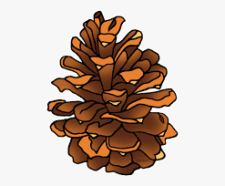 | Maple Leaf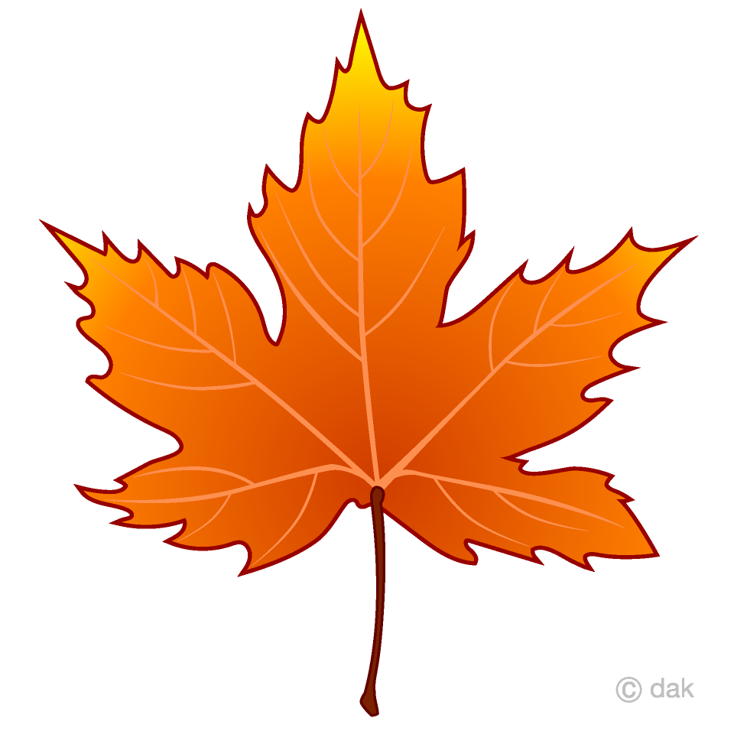 | Animal Tracks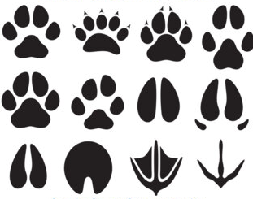 | Dogberries
Insect  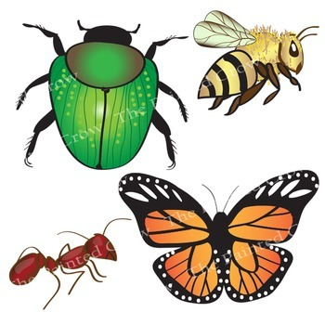 | Purple Flower  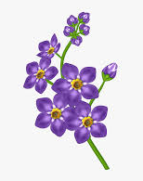 | Moss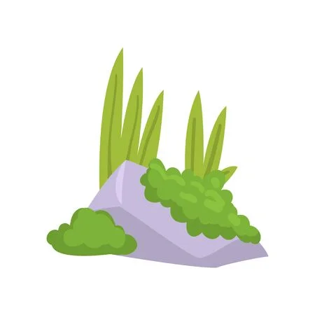 | Spider Web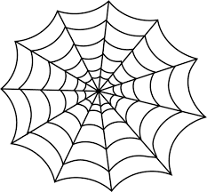
Squirrel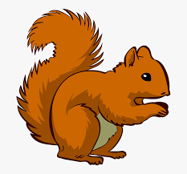 | Mushroom  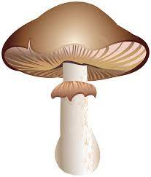 | Animal Home  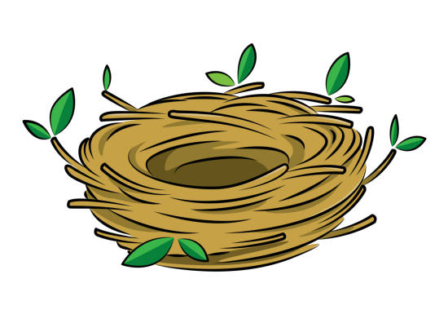 | Feather  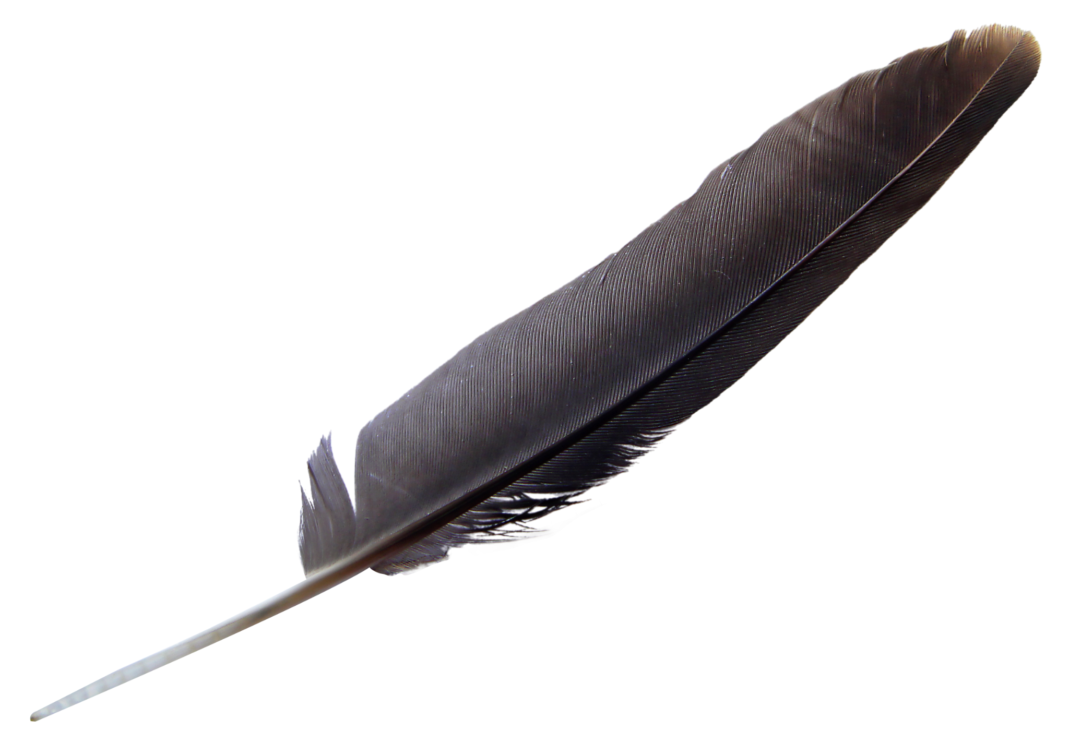
“Old Man’s Beard” Usnea Lichen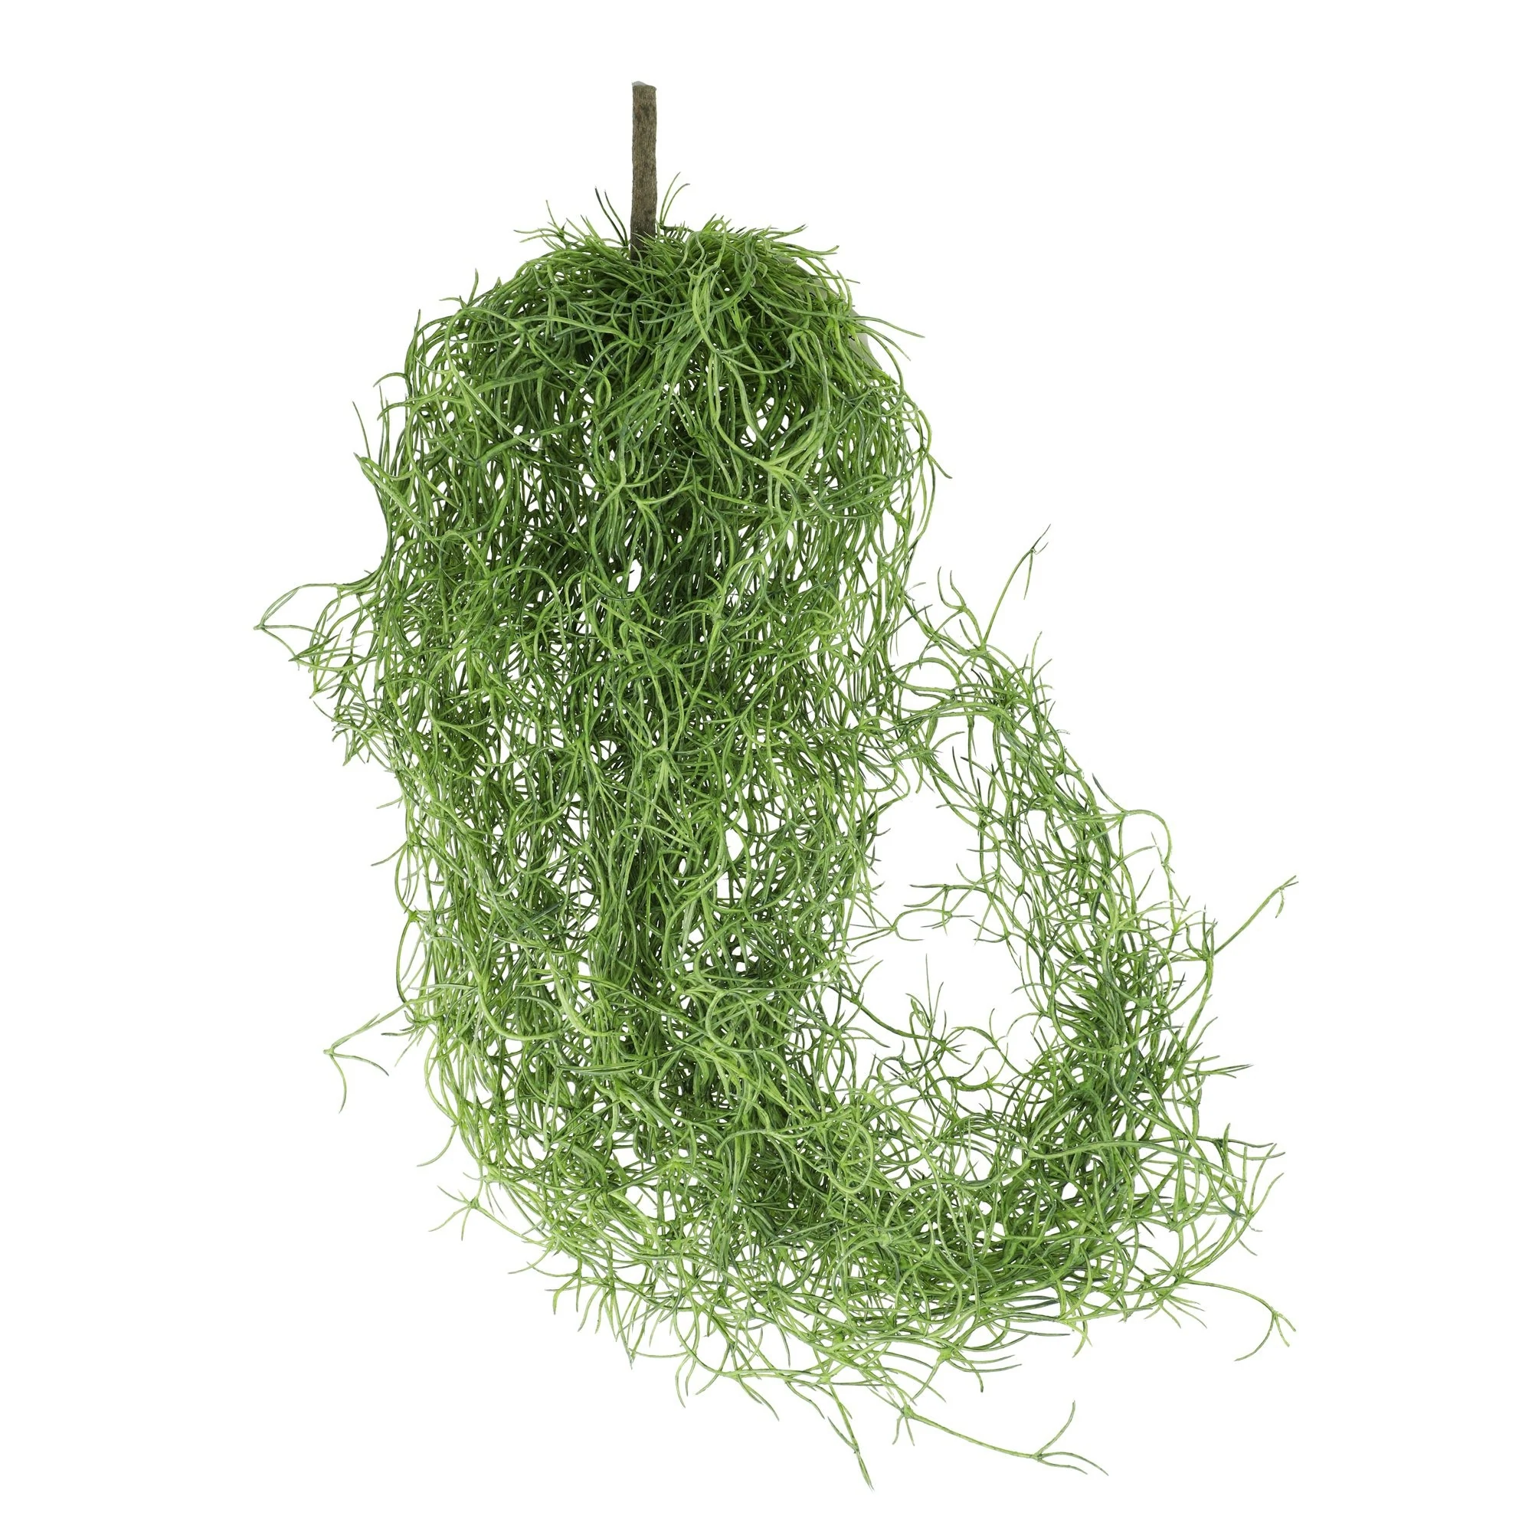 | Fallen Tree  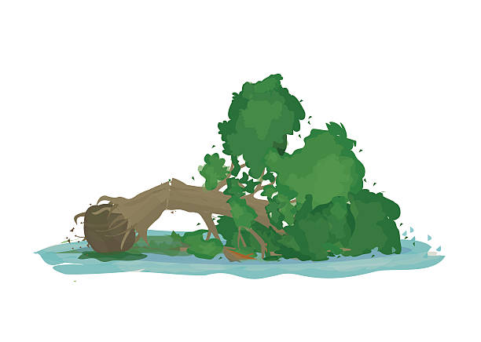 | Bird in Flight | Rocks  