Species at Risk Program
Stewardship Association of Municipalities (SAM)

Created by: Outreach Coordinator Karleena Squires

This programming is appropriate for grades K-12 - activities can be chosen/adapted based on their ages. This program can be delivered in person or virtually and provides instructions for both.

OBJECTIVE

Participants will spend time learning about several Species at Risk throughout Newfoundland and Labrador, to understand their value and the important roles they play across various ecosystems. This program provides knowledgeable building blocks for a lifetime of active and thoughtful engagement with Species at Risk habitats and other natural spaces. Participants will:
- Achieve greater awareness, understanding and appreciation of the environment;
- Learn more about Species at Risk in Newfoundland and Labrador and their habitats;
- Learn some of the threats facing Species at Risk in Newfoundland and Labrador;
- Engage and learn through exploration and conservation activities;
- Experience time in the outdoors.

OUTLINE

- Introduction and Species at Risk Presentation
- Activity (complete at least 3-5 activities depending on the event’s time length and age of the group)
All Ages / Younger Groups / Older Groups
  - Interpretive Walk
  - SARA Videos
  - Species at Risk Category Match-Up
  - Biodiversity Hoops
  - Symbiosis Shuffle Tag
  - Home Sweet Home
  - Species at Risk Jeopardy
  - Think Globally, Act Locally*
*We encourage the older groups to complete or plan a community engagement project as one of their activities.
- Closing

Prior to the meeting, confirm time, location(s), number of attendees, and presence of supplies with the group/class leader.

INTRODUCTION

- Introduce yourself - who are you, your position, what you do, etc.
- Land Acknowledgement: In the spirit of respect and friendship, we acknowledge that we practise conservation on traditional lands that have been, and continue to be, inhabited by the Indigenous Peoples of Newfoundland and Labrador. We are thankful to all the generations of people who have cared for these lands, and recognize and deeply appreciate their historic connections to these places. SAM recognizes our shared responsibility in conserving these special places and seeks to assist communities in achieving this goal.
- Introduce SAM, here are a few important notes:
  - SAM helps protect important habitats in our province.
  - What is a habitat?
    - Everything an animal or plant needs to survive: all habitats need to have food, shelter and water.
  - What are some examples of habitats in your community?
  - SAM helps to conserve important habitats within many communities across the province. (Include an example from their community if they are a SAM Community).
  - What are some threats that we would need to protect these habitats from?
    - Climate change, development, pollution, flooding, etc.
  - Present the Species at Risk Presentation - you will notice there are speakers’ notes on the slides, you can use these to compliment the slides and provide more information. If you are doing a walk, these are great speaking points and we recommend bringing them along.

ACTIVITY: INTERPRETIVE WALK

- In person? Invite SAM to help run your walk or run it yourself!
- If the weather permits, start the event off with an interpretive walk - programming activities can be completed along the walk.
- Recommended walk location would be a local wetland, forest, known wildlife habitat, or your community’s conservation area if they are a SAM Member. If you know of any Species at Risk habitat in the area, please be wary of any rules and regulations in the area and be mindful of where you step!
- Provide information about the habitat, use the speaker’s notes from the presentation while in the field for guidance.

ACTIVITY: SARA VIDEOS

- In-person or Virtual.
- Watch the following videos:
  - Kindergarten - Endangered Animals: https://www.youtube.com/watch?v=ZafzTEr2AsI
  - Grades 1-6 - WWF What is an Endangered Species: https://www.youtube.com/watch?v=6tjDCZrGnxc
  - Grades 7-12 - CBC Biodiversity Report: https://www.youtube.com/watch?v=1MOgg1M6egY

ACTIVITY: SPECIES AT RISK CATEGORIES MATCH-UP

- Completed In-person.
- Supplies needed: Several sets of “Species at Risk Categories Cards” (Appendix A) - each set should be marked with a colour/number on the back so each team knows which ones belong to them. Approximately 1 set per 3-5 kids (aim to have at least 4 sets for 20 participants).
- If possible, get access to the room/area 5 minutes beforehand and hide all of the cards in the room. If there is no early access, ask one of the leaders/teachers to assist with hiding them while you are doing your introduction. If not able to, simply mix up all the cards and scatter them in the general vicinity.
- Divide into teams. Assign each team a colour/number (corresponding to the set of Species at Risk Category Card). Explain to each team that hidden/scattered around the room are cards with the 5 different categories of Species at Risk. Team members must search for their cards until all are located. Once they are all located, the teams must match the Species at Risk Category with the corresponding definition and example. Younger groups may need help reading. First one to finish wins!

ACTIVITY: BIODIVERSITY HOOPS

- Completed In-person, Outside.
- Supplies:
  - Hula Hoops (1 per group), or long length of string that they can make a loop with
- Take the group to an outdoor area.
- First- Ask if anyone can define Biodiversity - bio = life, diversity = variety. Ask why biodiversity is important?
- Put students in small groups and tell them that they are going to have a competition to see which group can find the most diversity in an area. Give each group a hula hoop/length of string. Tell groups that they are allowed to place their hoop anywhere in the outdoor area then they must record how many different types of plants and animals are in this area. Give the groups a 5 minute time limit.
- Have each group present the results of their Biodiversity Hoops. Compare and contrast the areas that had the most and least amount of biodiversity. Discuss what habitats/areas had higher/lower levels of biodiversity and why? What other information could you collect about your surrounding environment that could influence your hoop?
- Discuss ways that you could increase biodiversity. Some ideas include: plant a variety of native plants, add habitat for animals by putting up nesting boxes for birds, bats and bee houses, put up bird feeders and bird baths, etc.

ACTIVITY: SYMBIOSIS SHUFFLE TAG

- In-person
- While it is recommended for younger groups, assess the group and play accordingly with any age.
- Ask what is symbiosis? An interaction between organisms where at least one organism benefits. Can anyone think of any examples in nature?
- Blue Felt Lichen (pictured in Appendix B)
  - a large, blue-grey, leafy lichen
  - often has ridges and curves that result in a scallop shape
  - found on broad-leaved trees in moist habitats; preferring cool, humid woodlands
  - in Newfoundland, this species grows mainly on Yellow Birch but has been found on White Spruce, mossy boulders, and non-native trees
  - only found in the Atlantic region within Canada
  - a cyanolichen, meaning it is actually a fungus and cyanobacteria partnership
  - only lichen of this type that is found in North America
  - species that rely on relationships with other species are often at greater risk because they rely on the health of many components of their ecosystem
- In Symbiosis Shuffle, the goal is to grow as many blue felt lichen as possible
- Assign:
  - 2 Taggers
  - Divide everyone else into Lichen and Trees
- The goal is for the Lichen and Trees to form pairs to grow the Lichen. Play some music and have everyone spread around the room. Start moving/dancing/swaying. When the music stops Lichen and Trees must pair up before being tagged. If they are tagged they sit out the rest of the round. Play multiple rounds if you have time.
- After the game, ask them what they think the taggers may represent that is preventing the Blue Felt Lichen from growing? - human activity, climate change, etc. How could you improve the growth?

ACTIVITY: HOME SWEET HOME

- In-person or Virtual.
- Supplies:
  - Paper
  - Drawing/colouring utensils
- What is a habitat? What does it provide? (Food/Water/Shelter)
- Habitat loss is the biggest threat to Species at Risk. What are some ways we can help protect wildlife habitat?
- Take some paper and drawing utensils and design the perfect wildlife habitat.
- Assign each person or groups of people a specific animal at risk to design their habitat around - examples include: Polar Bear, Woodland Caribou, Harlequin Duck, Ivory Gull, Piping Plover, Short-Eared Owl, American Eel, Banded Killifish, Blue Felt Lichen, Long’s Braya, Atlantic Salmon, North Atlantic Right Whale, etc.

ACTIVITY: SPECIES AT RISK JEOPARDY

- In-person or Virtual.
- Supplies:
  - In person: projector and screen, Jeopardy link below
  - Virtually: Jeopardy link below
- Recommended to be completed as one of the last activities as many questions are covered throughout the programming.
- Jeopardy Game: https://jeopardylabs.com/play/species-at-risk-nl

ACTIVITY: THINK GLOBALLY, ACT LOCALLY

- In-person or Virtual.
- Supplies:
  - Copy of “Appendix C1”- 1 per group
  - “Appendix C2” can be used to prompt responses
  - Writing utensils
- Despite the challenges and difficulties many species encounter, there are individual actions we can take that will help relieve some of the threats facing Species at Risk. Some actions are more involved, with a longer time commitment, while others take very little time to accomplish. It is important to weigh the potential effectiveness of possible actions to determine the right steps to take.
- This activity considers various actions and outcomes to respond to many of the potential threats faced by Species at Risk.
  - For each “Potential Threat” listed in this chart (as a class discussion or in small groups) add as many ideas as you can think of to fill in the description and the associated personal actions/potential solutions.
  - The last two columns can be filled in at the same time:
    - First evaluate the degree of personal commitment each idea would involve, rating the ideas: Easy, Medium, or Difficult.
    - Then evaluate the degree of effectiveness for each idea: Unlikely, Somewhat Likely, Very Likely.
  - Ask everyone to look at the completed charts and determine whether there are any potential “actions” that they have done in the past, are doing currently or might want to do as a result of evaluating the effectiveness of personal activities to address certain issues. Are there any actions best taken by a group of people, such as an environmental group at school?

Appendix A: Species at Risk Category Match-Up

Vulnerable | A species of low or declining population, small habitat range or other reasons that are causing concern to the species. | Polar Bear  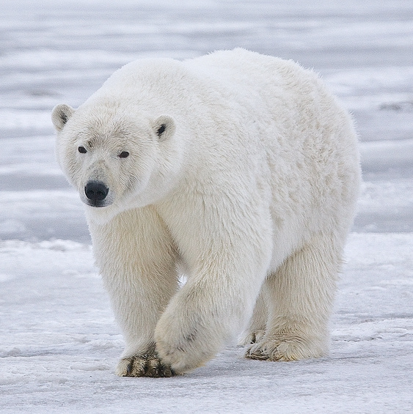
Threatened | A species likely to become endangered if things do not change. | Newfoundland Marten  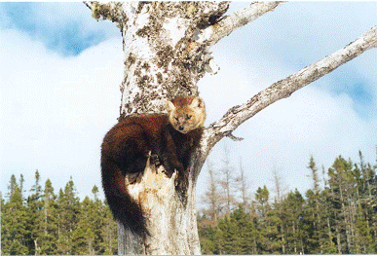
Endangered | A species threatened with extirpation or extinction over a large area in Canada. | Ivory Gull  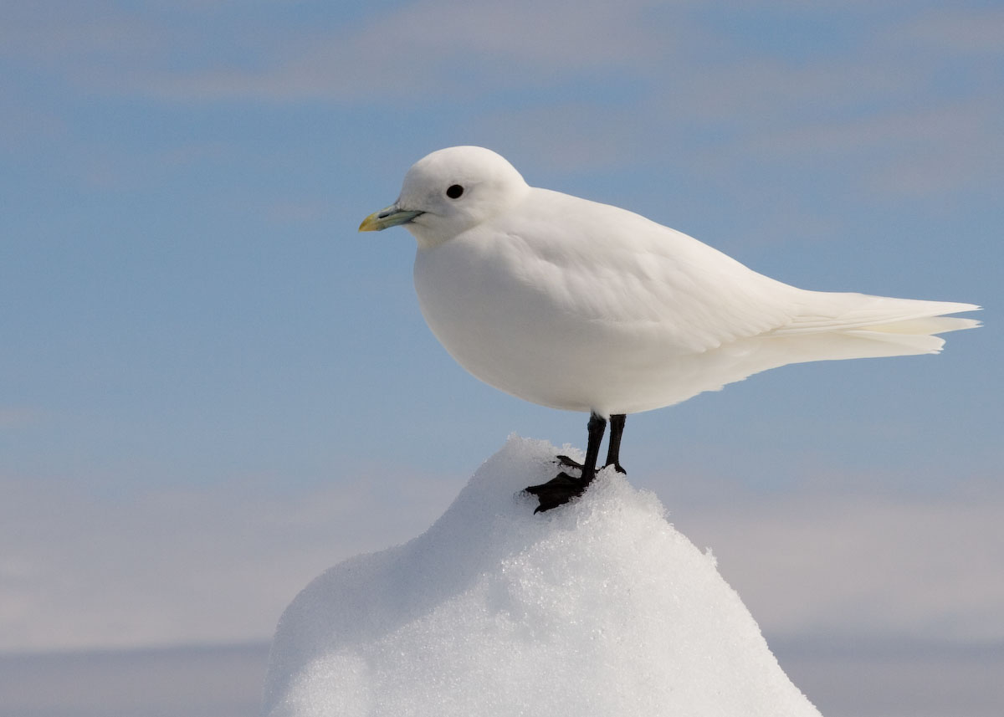
Extirpated | A species no longer found in the Canadian wilderness, but found in other places around the world. | Atlantic Walrus  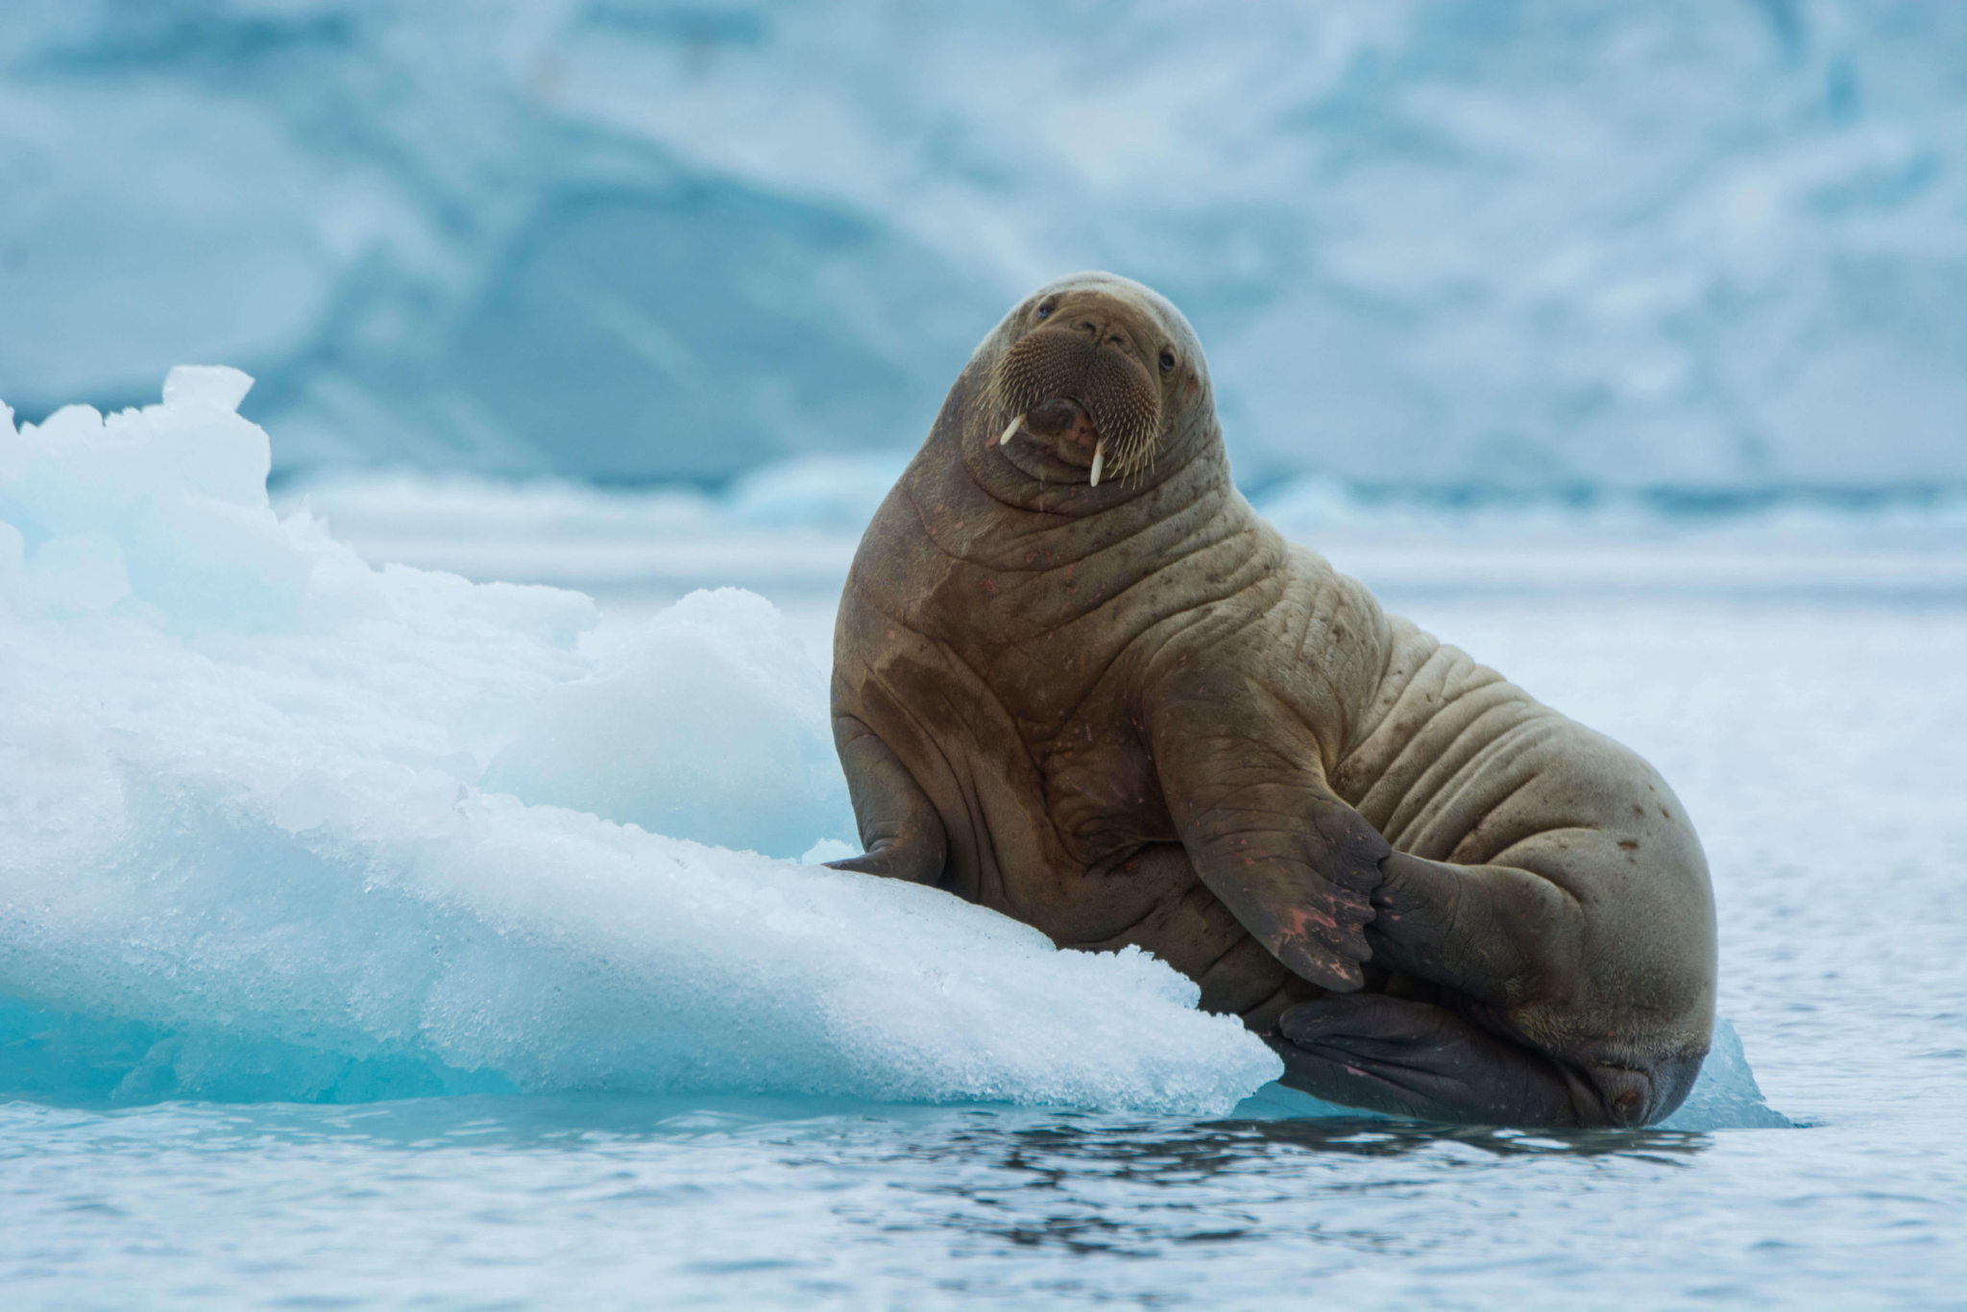
Extinct | A species that no longer exists. | Great Auk  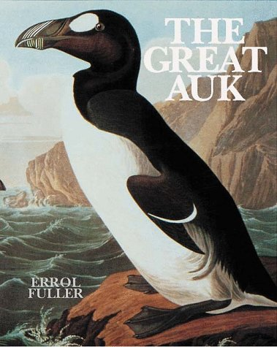

Appendix B: Blue Felt Lichen
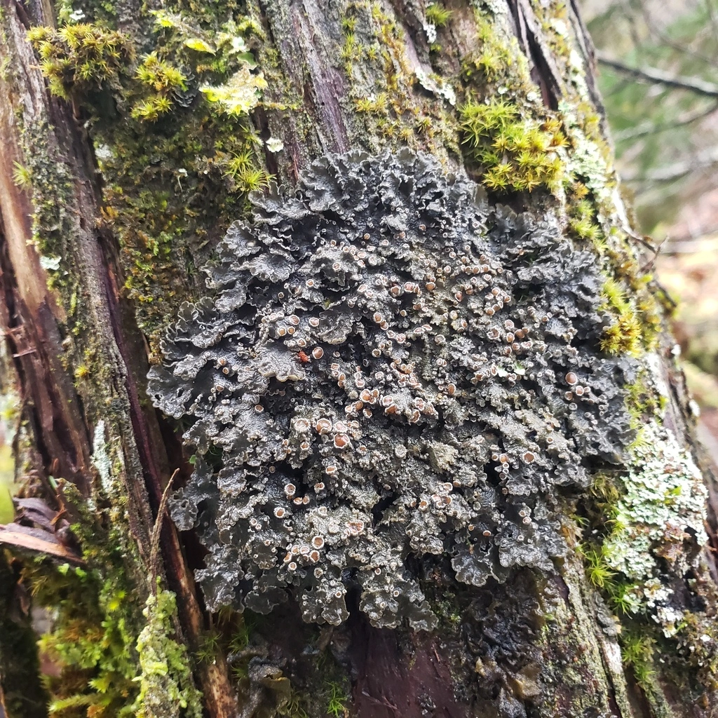

Appendix C1: Think Globally, Act Locally

Potential Threats for Species at Risk | Description of the Potential Threat | Personal actions/ potential solutions | Level of Commitment: Easy, Medium, Hard | Degree of Effectiveness: Unlikely, Somewhat Likely, Very Likely
Loss of/decrease of quality of habitat
Introduction of invasive/exotic species
Pollution
Disease

Appendix C2: Think Globally, Act Locally - Prompts

Potential Threats for Species at Risk | Description of the Potential Threat | Personal actions/ potential solutions | Level of Commitment: Easy, Medium, Hard | Degree of Effectiveness: Unlikely, Somewhat Likely, Very Likely
Loss of/decrease of quality of habitat | Wildlife habitat has been lost or destroyed due to human activity/development | - Encourage towns to conserve land (Join SAM)  - Plant trees  - Install nesting boxes | Medium  Easy | Very Likely  Very Likely
Introduction of invasive/exotic species | the introduction of a non-native species to an area, that may cause harm to other species or destroy habitats | - Participate in Citizen Science Activities to locate populations  - Do not transport plants/animals across borders without permits | Medium  Easy | Somewhat Likely  Somewhat Likely
Pollution | An introduction of chemicals or contaminants into the environment that has a negative effect | - Walk/bike/carpool  - Use less electricity  - Clean up litter and use reusable containers | Easy  Easy  Easy | Very Likely  Very Likely  Very Likely
Disease | Spread of illness through plants and animals | - Avoid touching wildlife  - Listen to local authorities on when not to feed animals  - Do not relocate wildlife | Easy  Easy  Easy | Very Likely  Very Likely  Very Likely

