**Wetlands 101 Program**

# Created by SAM’s Outreach Coordinator Karleena Squires

*Updated July 2025*

# This programming is appropriate for all ages - activities can be chosen or adapted to your group.

Feel free to present these activities on your own, or invite a SAM Staff Member to join you!

**OBJECTIVES**

Participants will spend time learning about wetlands in Newfoundland and Labrador; to understand their value and the important roles they play in maintaining biodiversity in our province. This programming provides knowledgeable building blocks for a lifetime of active and thoughtful engagement with wetlands and other natural spaces. Participants will:

* Achieve greater awareness, understanding and appreciation of the environment;
* Engage with their local wetlands through exploration and conservation activities;
* Experience time with what is beneficial to their mental and physical well-being, which can encourage continued exploration of nature;
* Learn about wetlands and their values, the threats they face, and be able to understand conservation efforts;
* Explain the benefits of wetlands to our communities.

# **PROGRAMMING OUTLINE**

* Introduction
* Wetlands 101 Presentation
* Activity (recommended to complete 3-5 activities)

**All Ages / Younger Groups / Older Groups**

* + Interpretive Walk
  + Wetland Metaphors
  + Name That Duck
  + Wetland Scavenger Hunt
  + Where Does the Water Go?
  + Conservation Brainstorming
  + Wetland Jeopardy
  + Printable Activities
  + Community Engagement*
* Closing

Prior to the meeting, confirm time, location(s), number of attendees, and presence of supplies with the group/class leader.

**INTRODUCTION**

* Introduce yourself to your audience.
* Land Acknowledgement: In the spirit of respect and friendship, we acknowledge that we practise conservation on traditional lands that have been, and continue to be, inhabited by the Indigenous Peoples of Newfoundland and Labrador. We are thankful to all the generations of people who have cared for these lands, and recognize and deeply appreciate their historic connections to these places. SAM recognizes our shared responsibility in conserving these special places and seeks to assist communities in achieving this goal.
* You may wish to introduce SAM, here are a few important notes:
  + Stewardship Association of Municipalities (SAM) is a non-profit organization in NL.
  + SAM works to secure, enhance, & restore important wildlife habitat in NL.
  + SAM does this by getting municipalities to sign Municipal Habitat Conservation Agreements with the provincial government, outlining Conservation Areas in their town that contain important wildlife habitat.
* Wetlands 101 Presentation - there are speakers’ notes provided on the slides, you can use these to compliment the slides and provide more information. If you are doing an interpretive walk or giving this program outside, these are great speaking points and we recommend bringing them along.

**ACTIVITY: INTERPRETIVE WALK**

* Interpretive Walks allow you to get your audience out in nature!
* If the weather permits, start your event off with an interpretive walk – some programming activities can even be completed along the walk!
* Recommended walk locations could include a local wetland, or your community’s Conservation Area if they are a SAM Member.
* Provide information about the wetland, including pointing out some cool features you see along the way. You can use the speaker’s notes from the presentation while in the field for guidance.
* Check out our document on how to host an Interpretive Walk
  + https://www.samnl.org/free-educational-resources

**ACTIVITY: WETLAND METAPHORS**

* Supplies needed:
  + Copy of Appendix A (1 per participant/group), writing utensil
  + Optional: have the following items on hand or just show a photo them - pillow, soap, whisk, sponge, egg (plastic or real), strainer, granola bar, water bottle
* Depending on the size of your audience, participants can complete this in groups or on their own.
* Give each participant/group a copy of Appendix A – Wetland Metaphors Matching Sheet and something to write with. Younger kids may have difficulty with writing – pairing them up with older kids or just having them answer out loud may be easier for them.
* Each item shown represents the many values of a wetland, have them match what they think each item represents. If you have the items on hand, spread them out on a table for everyone to see or hold them up in front of the group.
  + Granola Bar - wetlands provide food.
  + Sponge - help with flood and drought mitigation as wetlands act like giant sponges, soaking up rain and snowmelt and slowly releasing water in drier seasons.
  + Egg - wetlands are important nesting places.
  + Strainer - wetlands act like our kidneys and can remove harmful toxins and particles from the water.
  + Whisk - wetlands help to put important nutrients back into the water.
  + Soap - wetlands help cleanse the environment by absorbing carbon from the atmosphere.
  + Pillow - wetlands are a resting place for migratory birds along their journey.
  + Water Bottle - wetlands provide drinking water.

**ACTIVITY: NAME THAT DUCK**

* Supplies needed: Duck ID Slides (located at the end of the Wetlands 101 Presentation), copies of Appendix B: Duck ID Guide (1 per person/group), writing utensil, paper
* There are 2 ways to complete this activity:
  + Show the slides on the screen and have participants use their Duck ID Guides to correctly identify the species of duck on screen.
  + Print the slides (in colour if possible) and hang them up around the room. Have participants use their Duck ID Guides to correctly identify the species. The ducks are numbered 1-10 so have them list the number and duck species on their paper.

**ACTIVITY: WETLAND SCAVENGER HUNT**

* Supplies: Appendix C: Scavenger Hunt List (1 copy per person/group) – if completing this activity inside, an extra copy should be printed.
* Visit a local wetland to see how many items you can locate! If you cannot get out to visit a local wetland, hide the items around the room to be located.

**ACTIVITY: WHERE DOES THE WATER GO?**

* This activity requires Adult Supervision/Assistance.
* Supplies needed: 2 shoebox-sized plastic containers, 2 plastic bags, garden soil, piece of sod (or similarly absorbent items such as a towel or piece of carpet), scissors/craft knife, straw, some heavy books or blocks of wood, 2 buckets/larger containers, 2 cups, measuring cup, water, tea bag, small spoon or wire whisk
* Discussion:
  + Where does your community’s drinking water come from?
  + Where does it go?
  + How is it used?
  + Is anything added to the water before discharging it?
  + Have you ever noticed that rivers and ponds can look brown after a big storm?
    - Heavy rains can wash soil and other materials into the water. This is known as siltation. Sediment can contain harmful chemicals that cause pollution.
  + Wetlands and the plants within act as natural filters like the kidneys in our bodes - trapping sediment and filtering out toxins the way our kidneys protect us or a strainer traps spaghetti while allowing water to run down the drain. By trapping and absorbing sediment, wetland plants help reduce pollution problems downstream.
* Using Appendix D: Wetland Sediment Trap Instructions, make your own wetland sediment trap to demonstrate how wetlands act as natural filters (can be done individually or as a group).

**ACTIVITY: CONSERVATION BRAINSTORMING**

* Supplies needed: chart paper or other large paper, markers
* Divide into smaller groups, or complete as one large group.
* Explain the following scenario:
  + David just bought a new piece of land in the Town of Torbay. He is excited to build his first home, and the piece of land he bought is beautiful. There is a small pond behind the land, and a river runs just at the edge of his property into the pond. David has never owned land by a body of water before and is looking forward to his family using the pond for water activities such as swimming and kayaking.
  + One day, prior to building his new home, David visits his new property – he sees a family of ducks swimming in the pond behind his home and even sees a few splashes from some fish jumping after mosquitos above the water. He hears lots of birds in the trees around him and remarks on how peaceful it sounds, he is excited to have his family move in and his children grow up here.
  + After applying for the necessary building permits, David is informed by the Town that the pond is a protected wetland area, as the river and pond are home to many animals including nesting waterfowl and other bird species - this particular wetland is protected under a SAM Municipal Habitat Conservation Agreement. David has never heard of this and is surprised to learn he may face some issues when building his property: because it is a protected wetland, he cannot build within the surrounding riparian buffer (75 meters from the pond, 30 meters from the river) and he must keep the buffer intact. Curious, David reaches out to SAM to learn more about this Agreement and why these rules are in place - what is a riparian buffer and why must it be protected? How can David still enjoy his property?
  + Brainstorm: For the next 10 minutes, you work for SAM!
    - How would you explain to David about the Conservation Agreement?
    - What are some reasons to protect the riparian buffer?
    - What are some ways he can still enjoy the pond and river next to his property?
    - Remember: a Habitat Conservation Agreement does not prevent people from doing what is already legal to do in the area, it just helps both the municipal and provincial government to decide on if a development is helpful or harmful to important wildlife habitat.

**ACTIVITY: WETLAND JEOPARDY**

* Supplies needed: projector, screen, Jeopardy game
  + Jeopardy Game: <https://jeopardylabs.com/play/wetlands-101-8>
  + You can clone and edit the game if you wish, without changing the original game.

**ACTIVITY: PRINTABLE ACTIVITIES**

* Supplies needed: Copies of Appendix E: Printable Activities, writing/colouring utensils
* Provide as a handout to be completed during your session, or it can be brought home.

**ACTIVITY: COMMUNITY ENGAGEMENT**

* Follow up on learning about Wetlands by completing a Community Service Act.
* Visit <https://www.samnl.org/> under our Resources Tab for possible action ideas.
* Action ideas can include, but are not limited to:
  + Constructing bird houses, nesting boxes, or bat boxes, instructions found here:
    - <https://www.samnl.org/enhance-and-restore-wildlife-habitats/>
    - <https://www.samnl.org/bats/>
  + Establishing a trail network within your community, or maintaining an already existing trail network
    - <https://www.samnl.org/trails/>
  + Create geocaches in areas where people can enjoy local wetlands
    - <https://www.samnl.org/geocaching/>
  + Petition or write letters to your municipal government to encourage them to protect wetlands in your community
  + Plant pollinator friendly species of plants that are native to your area
    - <https://www.samnl.org/wildlife-friendly-property/>
  + Organize a community clean-up or organize and maintain a waste reduction program at your school or within your group
    - <https://www.samnl.org/clean-up-litter/>
    - <https://shorelinecleanup.org/>
  + Organize an event for World Wetlands Day on February 2nd or recognize other important Environmental Awareness Days
    - <https://www.worldwetlandsday.org/>
    - <https://www.samnl.org/celebrate-environmental-awareness-days/>
  + Be a Citizen Scientist - take part in local data collection!
    - <https://www.samnl.org/citizen-science-programs/>
  + Develop a calendar with photos of local wetlands and sell them as a fundraiser, use the money to help support the wetland in some way such as designing and purchasing “No Littering” signs to put up in the area
  + Produce a newsletter with articles about wetland habitats and wildlife to distribute to your school or local community.
  + Develop a video, pamphlet, poster or other creative display to encourage wetland conservation.

**CLOSING**

* Thank everyone for listening and participating.
* For Girl Guides and Scouts, SAM is providing a special SAM Crest at no cost to participants, email [samengagement995@gmail.com](mailto:samengagement995@gmail.com) to arrange for pick-up/delivery of crests.

# **Appendix A: Wetland Metaphors Matching Sheet**

# 

|  |  |
| --- | --- |
| **________________________________** | **_________________________________** |
| **________________________________** | **________________________________** |
| **________________________________** | **________________________________** |
| **________________________________** | **________________________________** |

# 

# 

# **Appendix B: Duck ID Guides for Name that Duck Activity**

# 

# **Appendix C: Wetland Scavenger Hunt**

|  |  |  |  |
| --- | --- | --- | --- |
|  |  |  |  |
|  | Purple Flower   |  |  |
|  | Mushroom   | Animal Home   | Feather |
|  | Fallen Tree   | Bird in Flight   |  |

# **Appendix D: Wetland Sediment Trap Instructions**

Supplies: 2 shoebox-sized plastic containers, 2 plastic bags, garden soil, piece of sod (or similarly absorbent items such as a towel or piece of carpet), scissors/craft knife, straw, some heavy books or blocks of wood, 2 buckets/larger containers, 2 cups, measuring cup, water, tea bag, small spoon or wire whisk

Objective: To make your own sediment trap to see how wetlands help filter flowing water in streams and rivers.

Instructions:

1. Line the inside of each container with the plastic bag. Place 5 cm (2 inches) of garden soil over the bottom of one container. Cover half the soil with a thick piece of sod (or other absorbent material as noted above) and pack soil onto the other half until it is level with the base of the sod. The sod/absorbent materials represent plants in a wetland.
2. Fill the second container with garden soil to the same depth as the soil in the first box.
3. With scissors/craft knife, make one small hole (no larger than the drinking straw) on one end of each container, the hole should be just above the soil line. In the first container, the hole should be placed at the sod end.
4. Cut a straw in half, to make 2 small straws, and poke each half partway into each of the holes so that it pierces the plastic liner in the box. The straw will be the drain spout.
5. Set the two containers side by side at the edge of a table or counter, with the straw sticking out over the edge. Place a couple of books or pieces of wood under the back end of each container so that both boxes are sloped at the same angle. The slope will make the water move quickly, as it does in a fast river or stream.
6. Place a bucket/container on the floor under each straw to catch the water when it flows out.
7. Put 250 ml (1 cup) of water in each cup. Cut open a tea bag and sprinkle half of the tea into each cup. The tea leaves represent the sediment in the water. Stir up the water so the tea leaves float around.
8. Quickly pour one cup into the soil at the back of each container. Watch what happens to the water as it flows through the container and drains out the other end.
9. Check the water in the pail. Which pail contains the most tea leaves? What else is in the pails?

# **Appendix E: Printable Activities**

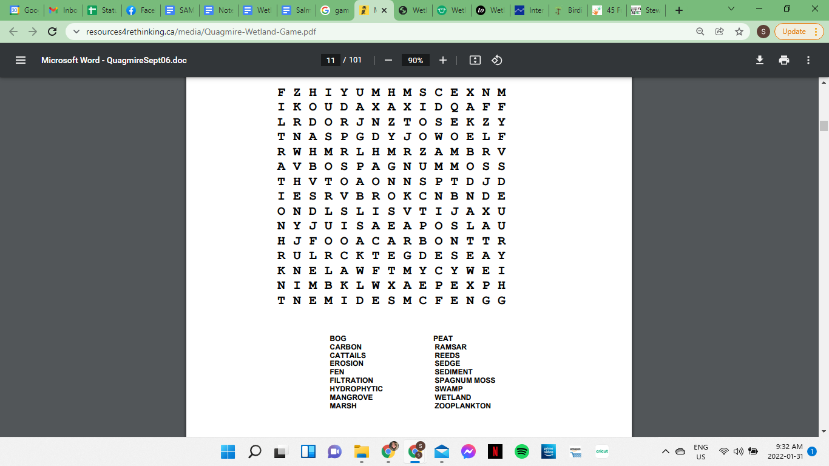

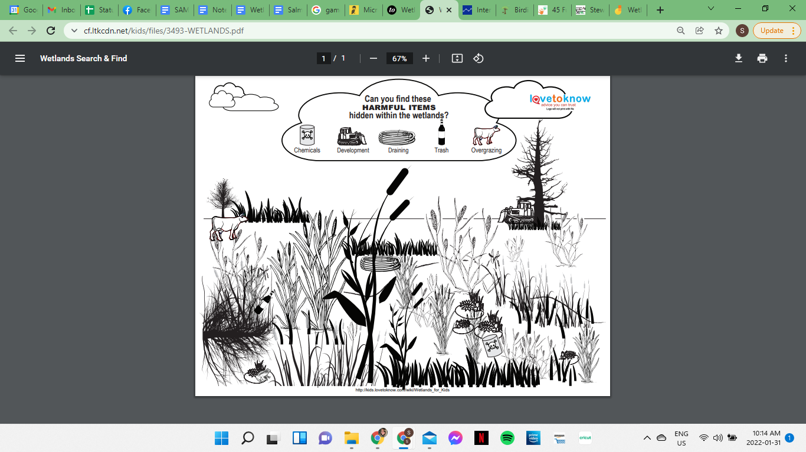

# **Colour Me In!**

