**Species at Risk Habitat Conservation Program**

# Created by SAM’s Outreach Coordinator Karleena Squires

*Updated May 2025*

# 

# This programming is appropriate for all ages - activities can be chosen or adapted to your group.

Feel free to present these activities on your own, or invite a SAM Staff Member to join you!

**OBJECTIVES**

Participants will spend time learning about Species at Risk in Newfoundland and Labrador; to understand their value and the important roles they play across various ecosystems. This programming provides knowledgeable building blocks for a lifetime of active and thoughtful engagement with Species at Risk habitats and other natural spaces. Participants can:

* Achieve greater awareness, understanding and appreciation of the environment;
* Learn more about Species at Risk in Newfoundland and Labrador and their habitats;
* Learn about the threats facing Species at Risk in Newfoundland and Labrador;
* Engage and learn through exploration and conservation activities;
* Experience time in the outdoors.

# **PROGRAMMING OUTLINE**

* Introduction
* Species at Risk Presentation
* Activity (recommended to complete 3-5 activities)

**All Ages / Younger Groups / Older Groups**

* + Interpretive Walk
  + SARA Videos
  + Species at Risk Category Match-Up
  + Biodiversity Hoops
  + Symbiosis Shuffle Tag
  + Home Sweet Home
  + Species at Risk Jeopardy (Versions for younger and older audiences)
  + Think Globally, Act Locally
* Closing

Prior to the meeting, confirm time, location(s), number of attendees, and presence of supplies with the group/class leader.

**INTRODUCTION**

* Introduce yourself to your audience.
* Land Acknowledgement: In the spirit of respect and friendship, we acknowledge that we practise conservation on traditional lands that have been, and continue to be, inhabited by the Indigenous Peoples of Newfoundland and Labrador. We are thankful to all the generations of people who have cared for these lands, and recognize and deeply appreciate their historic connections to these places. SAM recognizes our shared responsibility in conserving these special places and seeks to assist communities in achieving this goal.
* You may wish to introduce SAM, here are a few important notes:
  + Stewardship Association of Municipalities (SAM) is a non-profit organization in NL.
  + SAM works to secure, enhance, & restore important wildlife habitat in NL.
  + SAM does this by getting municipalities to sign Municipal Habitat Conservation Agreements with the provincial government, outlining Conservation Areas in their town that contain important wildlife habitat.
* Species at Risk Presentation - there are speakers’ notes provided on the slides, you can use these to compliment the slides and provide more information. If you are doing an interpretive walk or giving this program outside, these are great speaking points and we recommend bringing them along.

**ACTIVITY: INTERPRETIVE WALK**

* Interpretive Walks allow you to get your audience out in nature!
* If the weather permits, start your event off with an interpretive walk – some programming activities can even be completed along the walk!
* Recommended walk locations could include a local wetland, forest, known wildlife habitat, or your community’s Conservation Area if they are a SAM Member. If you know of any Species at Risk habitat in the area, please be wary of any rules and regulations in the area and be mindful of where you step!
* Provide information about the habitat, you can use the speaker’s notes from the presentation while in the field for guidance.
* Check out our document on how to host an Interpretive Walk
  + <https://www.samnl.org/free-educational-resources>

**ACTIVITY: SARA VIDEOS**

* Watch a video about Species at Risk:
  + Endangered Animals (appropriate for Kindergarten): <https://www.youtube.com/watch?v=ZafzTEr2AsI>
  + WWF What is an Endangered Species (appropriate for Grades 1-6): <https://www.youtube.com/watch?v=6tjDCZrGnxc>
  + CBC Biodiversity Report (appropriate for Grades 7-12): <https://www.youtube.com/watch?v=1MOgg1M6egY>

**ACTIVITY: SPECIES AT RISK CATEGORIES MATCH-UP**

* Supplies needed: Several sets of the “Species at Risk Categories Cards” found in Appendix A - each set should be marked with a colour/number on the back so each team knows which ones belong to them. Approximately 1 set for every 3-5 kids.
* If possible, get access to the room/area 5 minutes beforehand and hide all of the cards in the room. If there is no early access, ask one of the leaders/teachers to assist with hiding them while you are doing your introduction and presentation. If you are unable to hide them, simply mix up all the cards and scatter them in the general vicinity.
* Divide the group into teams. Assign each team a colour/number (corresponding to the set of Species at Risk Categories Cards). Explain to each team that hidden/scattered around the room are cards with the 5 different categories of Species at Risk. Team members must search for their cards until all are located. Once they are all located, the teams must match the Species at Risk Category with the corresponding definition and example. Younger groups may need help reading. First one to finish wins!

**ACTIVITY: BIODIVERSITY HOOPS**

* Supplies needed: Hula Hoops (1 per group), or long length of string in a loop (about 2m).
* Take the group outdoors and ask the following questions:
  + Can anyone define Biodiversity? (bio = life, diversity = variety).
  + Why is biodiversity important?
* Put students in small groups to try to find the most biodiversity. Give each group a hula hoop/length of string. Groups will place their hoop anywhere outdoors and they have 5 minutes to record how many different plants and animals are in their hoop.
* Each group will then present the results of their Biodiversity Hoop.
  + Discuss: Who had the most biodiversity? Who had the least? Why do you think that is? Did anything in the surrounding environment influence the content of your hoop? How could you have improved the biodiversity?
  + How could we increase biodiversity everywhere?
    - Some ideas include: plant a variety of native plants, add habitat for animals by putting up nesting boxes for birds, bats and bee houses, put up bird feeders and bird baths, etc.

**ACTIVITY: SYMBIOSIS SHUFFLE TAG**

* Ask what is symbiosis?
  + An interaction between organisms where at least one organism benefits.
  + Can anyone think of any examples in nature?
* Teach the group about Blue Felt Lichen (pictured in Appendix B):
  + a large, blue-grey, leafy lichen,
  + often has ridges and curves that result in a scallop shape,
  + found on broad-leaved trees in moist habitats, preferring cool, humid woodlands,
  + in Newfoundland, this species grows mainly on Yellow Birch but has been found on White Spruce, mossy boulders, and non-native trees,
  + only found in the Atlantic region within Canada,
  + a cyanolichen, meaning it is a partnership between a fungus and cyanobacteria,
  + only lichen of this type that is found in North America,
  + species that rely on relationships with other species are often at greater risk because they rely on the health of many components of their ecosystem.
* The goal of Symbiosis Shuffle is to grow as many Blue Felt Lichen as possible!
* Assign 2 Taggers, then divide everyone else evenly into Lichen and Trees (you can use something to identify who are Lichens vs Trees if needed).
* The goal of the game is for the Lichen and Trees to form pairs to grow the Lichen.
* Have everyone spread around the room. Play some music - when the music stops Lichen and Trees must pair up before being tagged by the Taggers. If they are tagged they are out. You can play multiple rounds if you have time.
* After the game, ask:
  + What do you think the Taggers might represent - preventing the Blue Felt Lichen from growing?
  + Answers could include: human activity, climate change, etc.
  + How could you improve the growth of the Lichen?

**ACTIVITY: HOME SWEET HOME**

* Supplies needed: Paper and Drawing/colouring utensils
* Ask:
  + What is a habitat?
  + What does it provide? (Everything an organism needs: Food + Water + Shelter)
* Development is the biggest threat to the habitat of Species at Risk.
  + What are some ways that we can help protect wildlife habitat?
* Using paper and drawing/colouring utensils, design the perfect wildlife habitat!
* To add to this activity: Assign individuals or groups a specific Species at Risk to design their habitat for: Polar Bear, Woodland Caribou, Harlequin Duck, Ivory Gull, Piping Plover, Short-Eared Owl, American Eel, Banded Killifish, Blue Felt Lichen, Bank Swallow, Leach’s Storm Petrel, Barren’s Willow, Long’s Braya, Atlantic Salmon, etc.

**ACTIVITY: SPECIES AT RISK JEOPARDY**

* Supplies needed: projector, screen, Jeopardy game
* Jeopardy Game: <https://jeopardylabs.com/play/nl-species-at-risk>
  + You can clone and edit the game if you wish, without changing the original game.

**ACTIVITY: THINK GLOBALLY, ACT LOCALLY**

* Supplies needed: 1 copy per group of Appendix C1, 1 copy of Appendix C2 for the presenter (can be used to prompt responses in the group), writing utensils
* Despite the challenges and difficulties many species encounter, there are individual actions we can take that will help relieve some of the threats facing Species at Risk. Some actions are more involved, with a longer time commitment, while others take very little time to accomplish. It is important to weigh the potential effectiveness of possible actions to determine the right steps to take.
* This activity considers various actions and outcomes to respond to many of the potential threats faced by Species at Risk.
  + Complete this either as a large group discussion or in small groups: For each “Potential Threat” listed in this chart add as many ideas as you can think of to fill in the description and the associated personal actions/potential solutions.
  + The last two columns can be filled in at the same time:
    - First evaluate the degree of personal commitment each idea would involve, rating the ideas: Easy, Medium, or Difficult.
    - Then evaluate the degree of effectiveness for each idea: Unlikely, Somewhat Likely, Very Likely.
  + Ask everyone to look at the completed charts and determine whether there are any potential “actions” that they have done in the past, are doing currently or might want to do as a result of evaluating the effectiveness of personal activities to address certain issues. Are there any actions best taken by a group of people, such as an environmental group at school?

**CLOSING**

* Thank everyone for listening and participating.
* For Girl Guides and Scouts, SAM is providing a special SAM Crest at no cost to participants, email [samengagement995@gmail.com](mailto:samengagement995@gmail.com) to arrange for pick-up/delivery of crests.

# **Appendix A: Species at Risk Category Match-Up**

|  |  |  |
| --- | --- | --- |
| **Vulnerable** | **A species of low or declining population, small habitat range or other reasons that are causing concern to the species.** | **Polar Bear** |
| **Threatened** | **A species likely to become endangered if things do not change.** | **Short-eared Owl**  Short-eared Owl (Northern) - eBird |
| **Endangered** | **A species threatened with extirpation or extinction over a large area in Canada.** | **Piping Plover**  Our story > Piping plover population making a comeback on Ontario's shores  - OPG |
| **Extirpated** | **A species no longer found in the Canadian wilderness, but can be found in other places around the world.** | **Atlantic Walrus** |
| **Extinct** | **A species that no**  **longer exists.** | **Newfoundland Wolf**  Newfoundland wolf - Wikipedia |

# **Appendix B: Blue Felt Lichen**

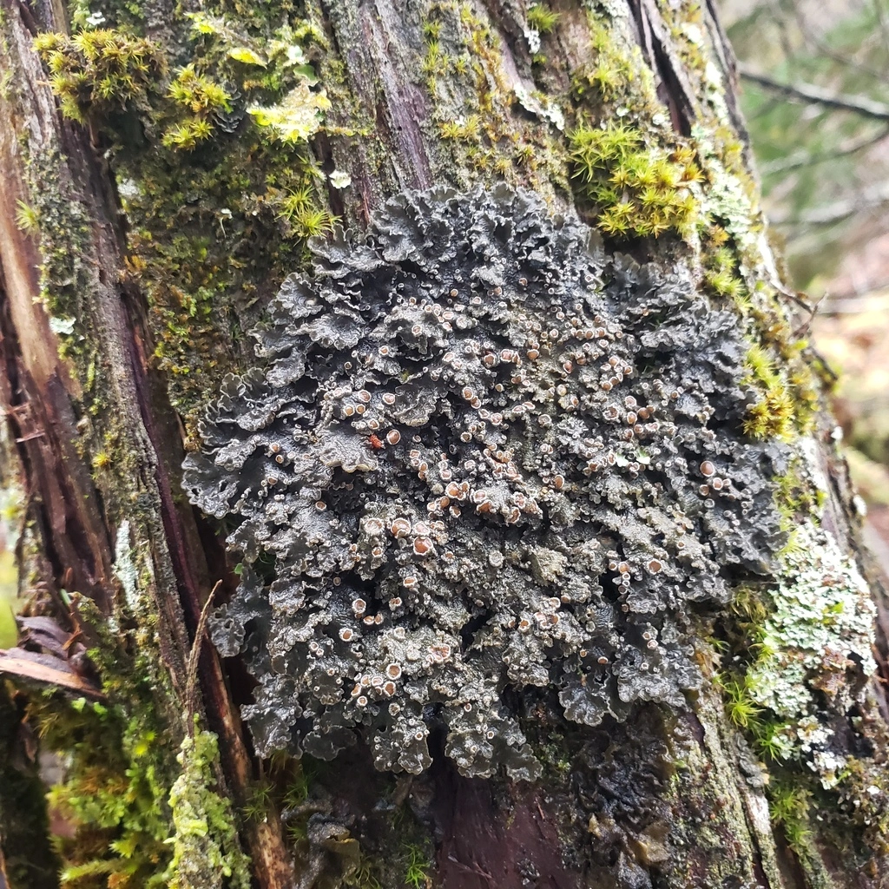

# **Appendix C1: Think Globally, Act Locally**

|  |  |  |  |  |
| --- | --- | --- | --- | --- |
| Potential Threats for Species at Risk | Description of the Potential Threat | Personal actions/ potential solutions | Level of Commitment: Easy, Medium, Hard | Degree of Effectiveness: Unlikely, Somewhat Likely, Very Likely |
| Loss of/decrease of quality of habitat |  |  |  |  |
| Introduction of invasive/exotic species |  |  |  |  |
| Pollution |  |  |  |  |
| Disease |  |  |  |  |

# **Appendix C2: Think Globally, Act Locally - Prompts**

|  |  |  |  |  |
| --- | --- | --- | --- | --- |
| Potential Threats for Species at Risk | Description of the Potential Threat | Personal actions/ potential solutions | Level of Commitment: Easy, Medium, Hard | Degree of Effectiveness: Unlikely, Somewhat Likely, Very Likely |
| Loss of/decrease of quality of habitat | *Wildlife habitat has been lost or destroyed due to human activity and/or development.* | * *Encourage towns to conserve land (Join SAM)* * *Plant trees* * *Install nesting boxes* | *Medium*  *Easy* | *Very Likely*  *Very Likely* |
| Introduction of invasive/exotic species | *The introduction of a non-native species to an area, that may cause harm to other species or destroy habitats.* | * *Participate in Citizen Science Activities to locate populations* * *Do not transport plants/animals across borders without permits* | *Medium*  *Easy* | *Somewhat Likely*  *Somewhat Likely* |
| Pollution | *An introduction of chemicals or contaminants into the environment that has a negative effect.* | * *Walk/bike/carpool* * *Use less electricity* * *Clean up litter and use reusable containers* | *Easy*  *Easy*  *Easy* | *Very Likely*  *Very Likely*  *Very Likely* |
| Disease | *Spread of illness through plants and animals.* | * *Avoid touching wildlife* * *Listen to local authorities on when not to feed animals* * *Do not relocate wildlife* | *Easy*  *Easy*  *Easy* | *Very Likely*  *Very Likely*  *Very Likely* |